**Computer Science Mentor Center**

Discrete Math Interview

**Guidelines**

# Problem-solving Interview

Discrete Mathematics has a significantly large content, covered by more than a course. To keep the interview within a reasonable amount of time (usually between 30 to 60 minutes), the mentor candidate is asked to provide the answers to some questions and construct a couple of valid proofs while explaining each of them using a step-by-step approach.

# Pretend to be a student

One of the main goals of the Discrete Math Interview is to check how comfortable the mentor candidate is with the subject and how well the content is explained to students. For that, the interviewer may at times assume the role of a student, asking questions and pretending to be confused regarding some points to better explore the candidate explanations.

# Good candidate with specific issues

Some candidates are very good overall but lack the necessary skills when it comes to a specific topic. In these cases, the candidate may be considered for hiring with the condition that they review the necessary material and/or participate in some review sessions at the CSMC. Other candidates may be very good in all topics but perform poorly while explaining and/or having unusual ways of communicating. It is up to the interviewer to make a decision whether or not to use additional problems, consider hiring a candidate under certain circumstances, or rejecting a candidate.

# Additional problems

Some candidates may need additional problems for various reasons, including: nervous start of interview, dubious answers, long time since last discrete math practice, confusing explanations, among others. In these cases, a sincere talk while trying to calm down the candidate may help identify the main issue. Doing so before working on additional problems might calm down nervous candidates and give the interviewer a better understanding of their capabilities (please refer to the last section for examples of additional problems).

# First proof

It is a good idea to start the interview with a proof from the chapters covered in 2305. For example:

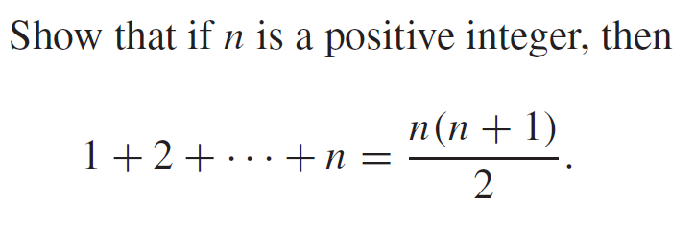

In case the interviewer deems necessary, any proofs from chapter 5 may be requested.

## Pay attention to:

**Conceptual understanding:** make sure they know what the concepts are and how to explain them, such as sets, propositions, induction, and so on.

**Template:** make sure they know the template used for the proofs by mathematical induction

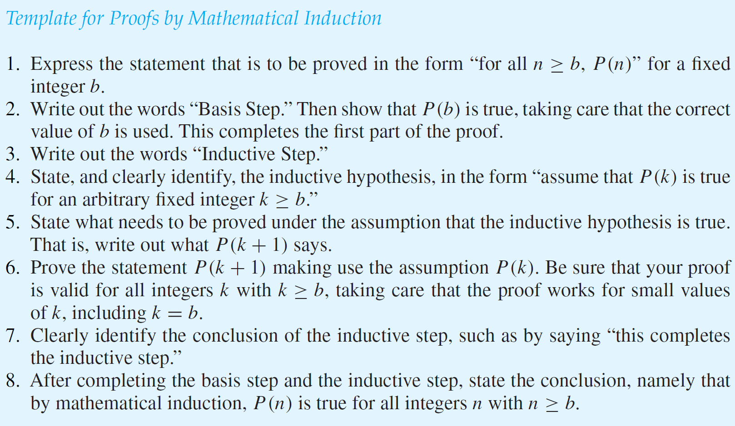

# Second problem

An additional problem is needed for the chapters covered in 3305. An example would be:



In case the interviewer deems necessary, any problems from chapter 8 may be requested.

## Pay attention to:

**Conceptual understanding:** make sure they know what the concepts are and how to explain them, such as relations, bit strings, recursion, and so on.

### Examples of additional problems:

1. What is the size of the power set of the set {a,b,c,d}  **Answer:______D______**

(A) 4 (B) 8 (C) 15 (D) 16 (E) 32

2. An example of element of the Cartesian product of A={1,2,3} and B={a,b} is **Answer:_______D_____**

(A) (a,b) (B) (a,1) (C) (1,3) (D) (2,a) (E) a (F) 3

3. What is a correct proof strategy to prove that 𝐴 = 𝐵, where A and B are sets? **Answer:______E______**

(A) Prove that 𝐴 ∩ 𝐵 = 𝐵 (B) Prove that 𝐴 ⊆ 𝐵 (C) Prove that 𝐵 ⊆ 𝐴

(D) Prove that 𝐴 ∪ 𝐵 = 𝐵 (E) Prove that 𝐴 ⊆ 𝐵 ∧ 𝐵 ⊆ 𝐴

4. What is a correct proof to prove that 𝐴 ⊆ 𝐵, where A and B are sets? **Answer:______A______**

(A) Prove that ∀𝑥, 𝑥 ∈ 𝐴 → 𝑥 ∈ 𝐵 (B) Prove that 𝐴 ∩ 𝐵 = 𝐵

(C) Prove that ∀𝑥, 𝑥 ∈ 𝐵 ↔ 𝑥 ∈ 𝐴 (D) Prove that ∀𝑥, 𝑥 ∈ 𝐵 → 𝑥 ∈ 𝐴

(E) Prove that 𝐴 ⊆ 𝐵 ∧ 𝐵 ⊆ 𝐴

5. True or False: The empty set is an element of the power set of a set A. **Answer:______T______**

6. Give a recurrence relation for the sequence {𝑎n}, where each succeeding term is twice the preceding term. (5 points) Answer: ***an*=2*an-1* -or- f(n)=2f(n-1)**

7. What are the terms *a0, a1, a2, a7* of the sequence {an}, where an = ? (5 points each)

**Answer: 0, 0, 1, 3**

8. What are the terms a0, a1, a2, a5 of the sequence {an}, whose nth term is *n*! – 2n? (5 points each)

**Answer*:* -1, -1, -2, 88**

9. Find the best big-O function for the function. (5 points each)

1. _____5 $f\left(n\right)=1 + 4 + 7 + · · · + (3n + 1)$

_____
2. _____5 $g\left(n\right)=1 + 3+5+ 7 + · · · + (2n-1)$

_____
3. _____3 $f\left(n\right)=\frac{3 - {2n}^{4} - 4n}{{2n}^{3}- 3n}$

_____
4. _____7 $f\left(n\right)=1 + 2 + 3 + · · · + \left(n^{2}- 1\right)+ n^{2}$

_____
5. _____5 $f\left(n\right)=\left\lceil n+2\right\rceil ∙ \left\lceil n/3\right\rceil$

_____
6. _____7 $f\left(n\right)= {3n}^{4}+ \log_{2}{n^{8}}$

_____

**Choose your answer from among the following:**

1. 1

10. Find 141 div 7 Answer:______D______

(A) 0 (B) 1 (C) 2 (D) 20 (E) 21

11. Which pair of integers is congruent modulo 8? Answer:______C______

(A) 2,3 (B) 4,8 (C) 1,17 (D) -5,5 (E) 0,1

12. Find 141 mod 7 Answer:______B______

(A) 0 (B) 1 (C) 2 (D) 20 (E) 21

13. In order to compute (0h 45m 53s + 0h 15m 10s), what modulus do you use to express the answer in hours, minutes and seconds? Answer:______E______

(A) 0 (B) 12 (C) 24 (D) 30 (E) 60

# References

Rosen, K.H., Discrete Mathematics and Its Applications, 7th edition.